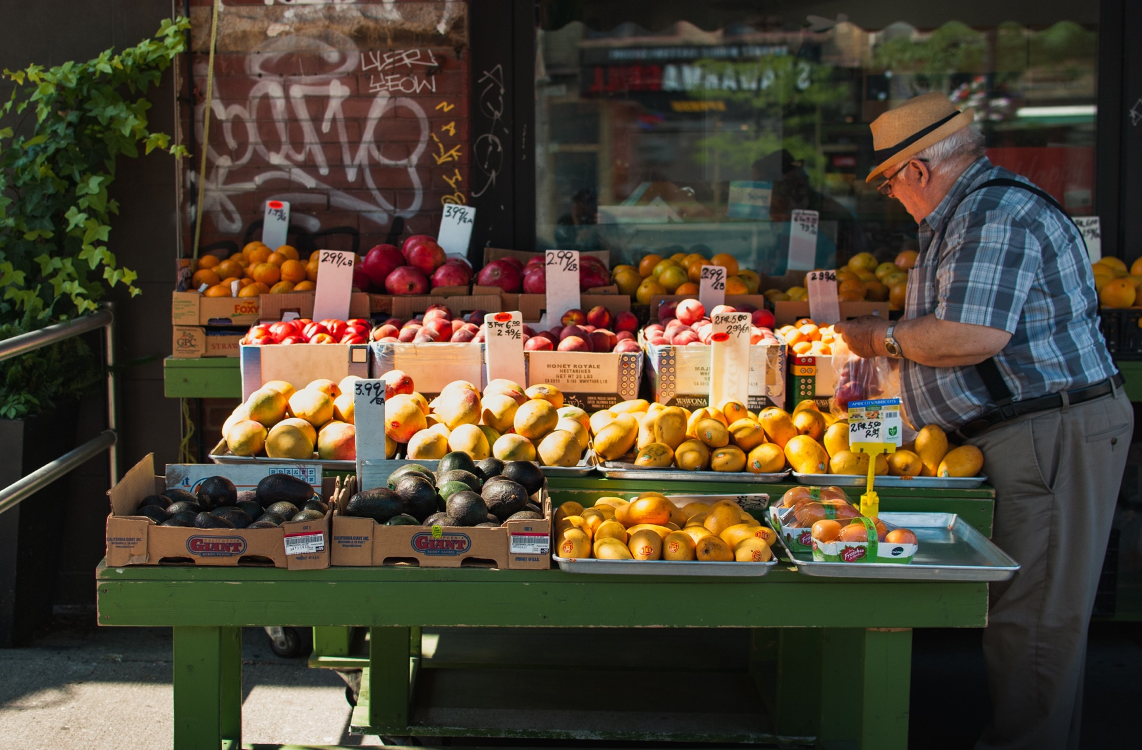



NEWSLETTER

December 2019

Issue

182

NEW SPECIAL AGRICULTUAL WATER RATE PROGRAM

In November the San Diego County Water Authority’s (SDCWA) Board of Directors approved a new and permanent agricultural water rate allowing new participants to join. The new agricultural water program rates will be decided in spring of 2020. The program will take effect January 1, 2021, replacing the current program that expires the end of 2020.

SDCWA has provided lower-cost water to growers in exchange for lower reliability since 2008 with their Transitional Special Agricultural Water Rate (TSAWR), when Metropolitan Water District of Southern California began to phase out a similar program.

The new program was developed by the Water Authority’s Fiscal Sustainability Task Force, which is assessing a variety of issues to ensure the agency’s long-term financial health. Regional farming leaders provided input to the task force on the parameters of the new program.

Farmers and growers who participate in the new program will continue to receive a lower level of water service during water shortages and emergencies. In exchange, participating farmers are exempt from fixed water storage and supply reliability charges.

Program details, such as the signup process and qualifying criteria, also will be developed early next year.

For more information please go to the SDCWA website link provided below.

<https://www.sdcwa.org/new-agricultural-water-program-benefits-san-diego-county-growers>



(760) 728

-

1178

|

3707

Old Highway 395, Fallbrook, CA

92028

1

.

1





2020 BOARD CALENDAR

At our December Board meeting the Board of Directors established the 2020 Board calendar with changes to the normal meeting dates for **August and December**. Our regular meetings of the Board of Directors are normally held the fourth Tuesday of each month and the November and December combined is held the first Tuesday in December. However, for these two meetings the dates will be changed to August 18, 2020 and the November and December combined meeting will be held on December 8, 2020 to accommodate for scheduling conflicts.

If you have additional questions, please contact Dawn Washburn at (760) 728-1178 ext. 129. For times and dates of our Board and Committee meetings please visit our website at [www.rainbowmwd.com/meetings](http://www.rainbowmwd.com/meetings)

2020 WATER AWARENESS CALENDARS COMING SOON

The North County Water Agencies (NCWA) Water Awareness Poster Calendar Contest (Contest) is an educational art contest for 4th grade students residing or attending schools within the service territories of the members of the NCWA. The Contest has two fundamental components; a picture (poster) drawing contest as well as production of a water awareness calendar featuring the poster drawing contest artwork.

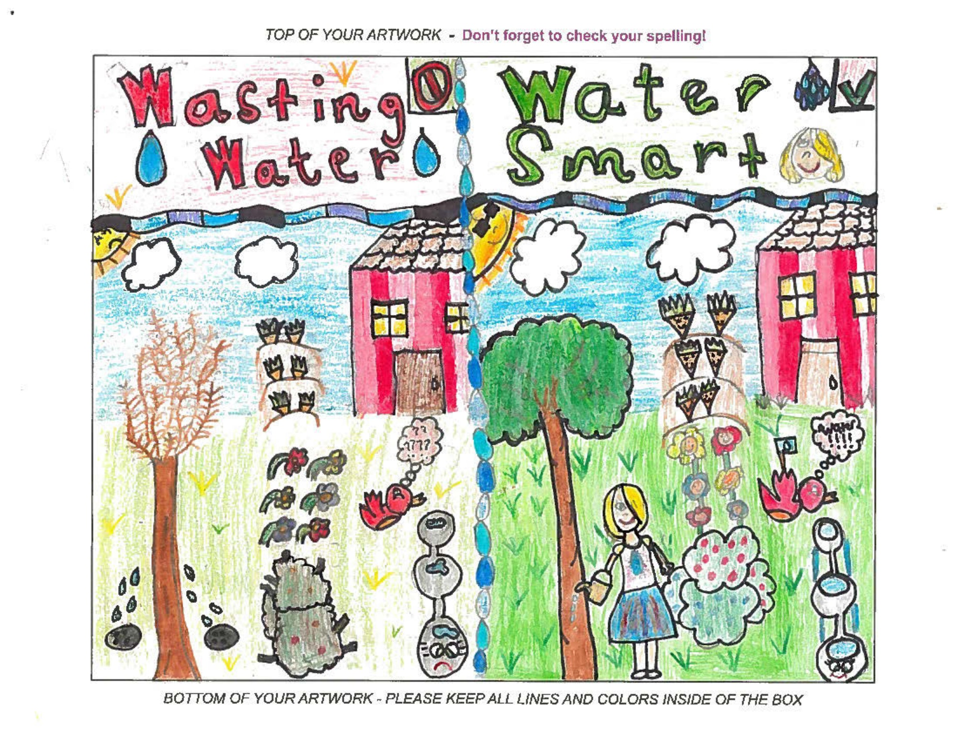

*Pictured Above*

*2016 Winner Kaitlyn Vitrano - Tied for 1st Place*

*Ms. Sinclair’s class at Bonsall Elementary School*

The contest starts at the beginning of each year. Each NCWA member agency distributes entry forms to those schools within their service boundaries. To enter the contest, students draw their pictures on the entry forms provided. The entry form instructs students to draw a picture illustrating the contest’s water awareness theme. This year’s theme is ***Love water, Save water***.

Last year’s entry winners are listed above and will be featured in the 2020 calendar. To see their amazingly creative artwork come get your 2020 calendar which will be available at the front counter of the District offices sometime mid-December.

# 

**2019 Contest Winners**

**Featured in the 2020 Calendar**

**1st Place** – Stephanie Reyes

* Teacher - Mrs. Kirk
* School – Vallecitos School District

**2nd Place** – Mia Cyr

* Teacher – Ms. McGough
* School – Bonsall Elementary

**3rd Place** – Noelia Romero

* Teacher – Mrs. Kirk
* School – Vallecitos School District



(760) 728

-

1178

|

3707

Old Highway 395, Fallbrook, CA

92028

2

.